BUSINESS PROCESS

s3-individual

Welles,Nick N.H.M.

2022-2023

Inhoudsopgave

My Business processes 2

Individual project 2

Group project 3

What is a Business process? 4

Operational processes 4

Strategic processes 4

Management processes. 4

Support processes. 4

Examples of business processes 4

What does a business process have to do with Software Engineering? 5

What is the cycle of a business process? 6

Design 6

Model 6

Execute 6

Monitor 6

Optimize 6

Source reference 7

# My Business processes

A business process is a process that has various scenarios with actions that must be performed to get to a particular goal. The goal that has been predefined has to be clearly noted. A business process is usually made in the form of a flowchart. An example of a business process will be placing an order to get a product from an online store. Which actions do you perform in order to get that product on your doorstep.

## Individual project

In my business process, the idea is that a customer can search for his/her desired product, then place it in the shopping cart and checkout by filling in user credentials.

The system will then check whether the products ordered are still in stock or not. The user will be notified of this.

If the system agrees, i.e. the product(s) is in stock, the user has entered the correct details and has paid, the user receives a notification back that the order has been confirmed.

[View image in full size](business%20process%20diagram%20-%20Instruweb.png)

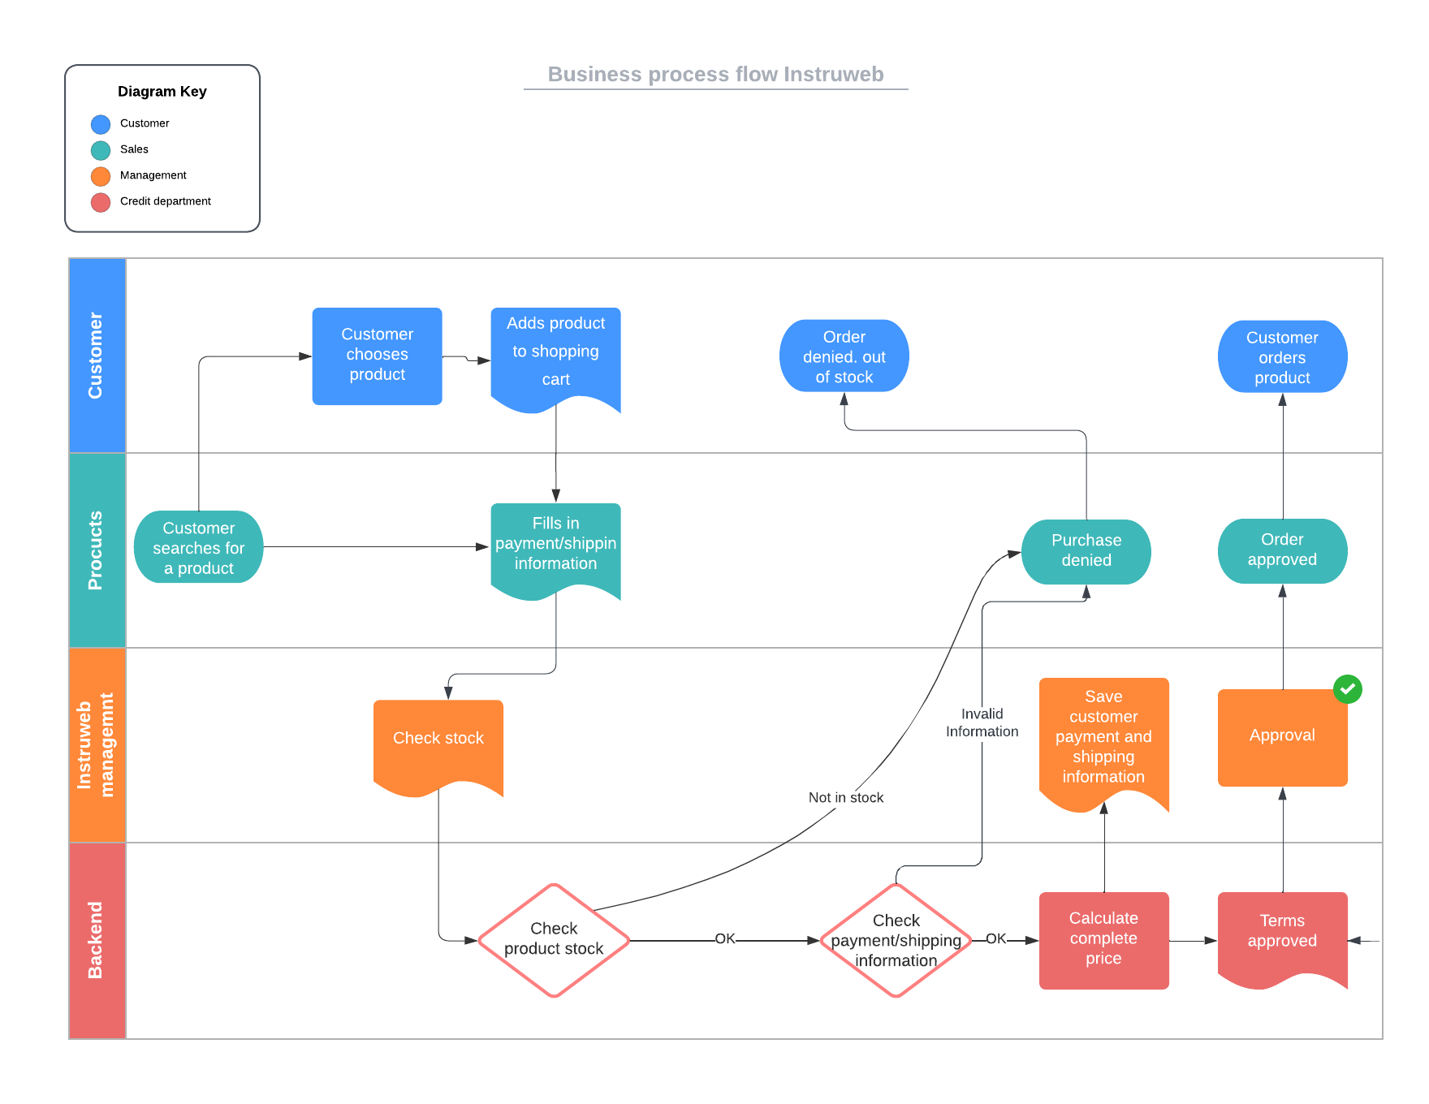

## Group project

In the group project for World Of Content myself and Jorn were responsible for the scraping of the data from the website. To make sure we understood the assignment correctly we made a business process diagram. This also helps our groupmates understand how the scraper works.

The scraper will start running when an administrator presses the start button in the admin dashboard. For that the administrator needs to be logged in. The scraper checks which retailers are enabled for scraping and then starts scraping from the base URL from the retailer. If the URL is invalid it will skip that URL and the scraper crawls another one. If all URL’s are found the scraper gets the data that corresponds to the product and compares the data. That data will be uploaded to the database and will be able for viewing in the front-end.

[View image in full size](https://raw.githubusercontent.com/WJJCN/Documentation/main/Documentatie/Afbeeldingen/WoC%20-%20Business%20process%20diagram%20scraper.png)

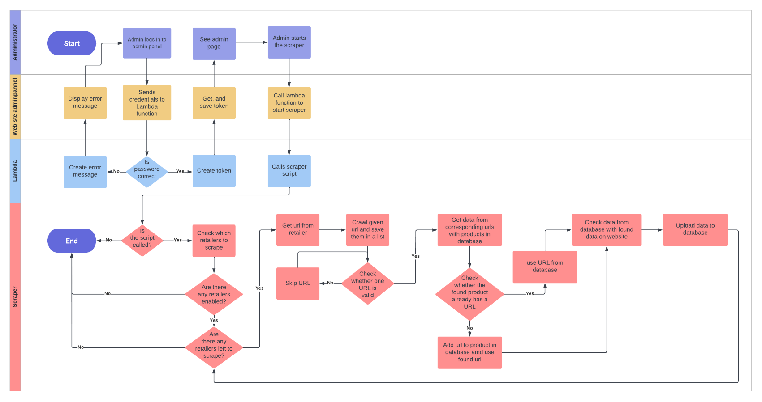

Research

# What is a Business process?

A business process is an activity or set of acts that must be performed to achieve a particular goal. This process must have a useful purpose and be clearly articulated. In almost all cases, this is in the form of a flow chart. Business processes come in different sizes business processes are usually broken down into smaller subprocesses that are interconnected.  
Different types of business processes are:

* Operational processes
* Strategic processes
* Management processes
* Supportive processes

## Operational processes

Operational processes are those directly related to the production of a product or service. These processes are often very complex and are often broken down into smaller processes.

## Strategic processes

Strategic processes are those that help the organization achieve its goals.

## Management processes.

Management processes are the processes that help the organization achieve its goals.

## Support processes.

Support processes are the processes that help the organization achieve its goals.

## Examples of business processes

An example of a business process is the process of ordering a product. This process begins with searching for a product on the organization's Web site. Next, the product is placed in the shopping cart and a payment method is chosen. Finally, the product is paid for and the product is shipped.

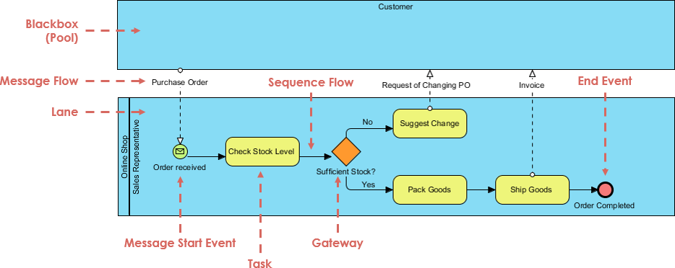

another example of a business process is making an appointment at the hospital or doctor's office. Using the flow below, you could also order a prescription from the pharmacy and come pick it up.

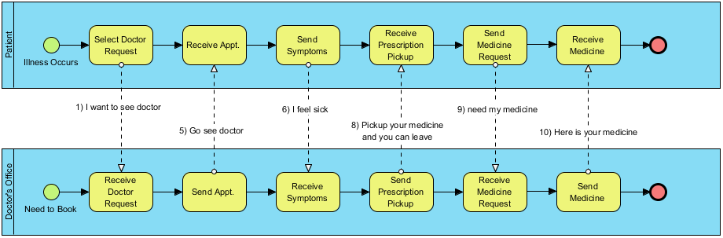

# What does a business process have to do with Software Engineering?

A business process has to do with software engineering because a business process is an activity or set of acts that must be performed to achieve a certain goal. This goal could be creating a Web site, creating an application or creating a software system. This goal must be clearly stated and must have a useful purpose.  
A good example here is the business process of the release process.  
But you can also see it the other way around. For example, a business process also needs software. This is to make a business process a lot more efficient and easier.

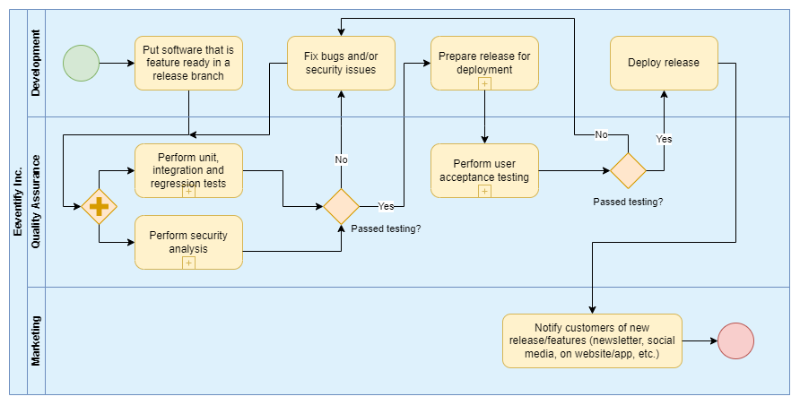

# What is the cycle of a business process?

The cycle of a business process is a cycle consisting of 5 steps. These steps are:

* Design
* Model
* Execute
* Monitor
* Optimize

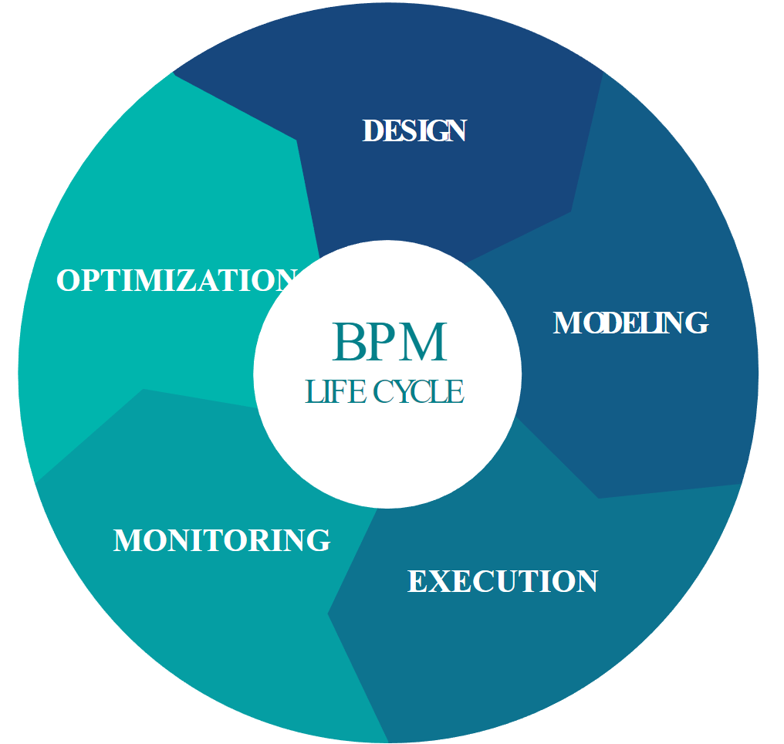

### Design

In the design phase, a business process is designed. In this phase, the objectives of the business process are considered. It also looks at the target audience of the business process. This is done to see if the business process is useful for the target group.

### Model

In the model phase, a model of the business process is created. The model is created using a flow chart. In this flow chart, a clear picture of the business process is given.

### Execute

In the execute phase, the business process is executed. In this phase, we check whether the business process works properly. Often through automated tests.

### Monitor

In the monitor phase, we check whether the business process is working properly. This is done by monitoring the KPI (Key Performance Indicator). The KPI is a measure of whether the business process is working well. If the KPI is not good, then we look at where the problem is and see how to fix it.

### Optimize

The optimize phase looks at how the business process can be improved. This is done by analysing the KPI. If the KPI is not good, it looks at where the problem is and looks at how the problem can be solved.

# Source reference

<https://circle.visual-paradigm.com/patient-business-process/>

<https://www.visual-paradigm.com/tutorials/as-is-to-be-business-process.jsp>

<https://www.gbtec.com/resources/bpm-business-process-management/>